**HEARING AID ON A MOULD**

**A BASIC GUIDE**

**Elbow .** This connects the aid to the tube. There are various different sizes depending on the aid.

[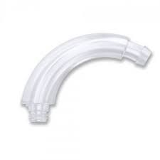](https://www.google.co.uk/imgres?imgurl=http://www.hearingaidparts.co.uk/wp-content/uploads/2016/07/PhonakEarHook.jpg&imgrefurl=http://www.hearingaidparts.co.uk/product/phonakunitron-ear-hook/&docid=Oa8Xzumd0tIULM&tbnid=gGy2fsTMRiS1-M:&vet=12ahUKEwisn62gytvdAhUeOsAKHZfXDVQ4ZBAzKDQwNHoECAEQNQ..i&w=225&h=225&safe=strict&bih=775&biw=1440&q=Phonak%20Nathos%20S%2BM%20hearing%20aid%20without%20elbow&ved=2ahUKEwisn62gytvdAhUeOsAKHZfXDVQ4ZBAzKDQwNHoECAEQNQ&iact=mrc&uact=8)

[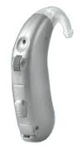](https://www.google.co.uk/imgres?imgurl=https://www.yourhearinghelper.com/sites/default/files/styles/large/public/hearing-aid/siemens_reflex_dsp_hearing_aid.png?itok%3DbyGBC1jM&imgrefurl=https://www.yourhearinghelper.com/hearing-aid/siemens-reflex-dsp-hearing-aid&docid=XuEuyI3vymk2rM&tbnid=QD2hYF2Zo8QeAM:&vet=10ahUKEwjHruPlt9vdAhXpCcAKHTaBA4AQMwh0KEQwRA..i&w=100&h=180&safe=strict&bih=775&biw=1440&q=siemens%20beige%20Reflex%20%20hearing%20aids%20uk&ved=0ahUKEwjHruPlt9vdAhXpCcAKHTaBA4AQMwh0KEQwRA&iact=mrc&uact=8) 

**Various types of hearing aid are provided on a mould but these all have an elbow to connect the tube of a mould to the aid.**

[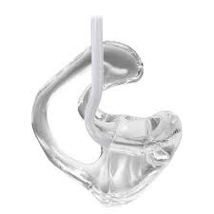](https://www.google.co.uk/imgres?imgurl=http://www.hearsogood.com/wp-content/uploads/2015/07/Earmold.jpg&imgrefurl=https://www.hearsogood.com/the-achilles-heel-of-a-good-hearing-aid-fit/&docid=ilEi71VpnKZgcM&tbnid=2lAgDvqtowqi-M:&vet=10ahUKEwjQqpufuNvdAhXBe8AKHbOxCsgQMwhUKBUwFQ..i&w=454&h=454&safe=strict&bih=775&biw=1440&q=ear%20mould&ved=0ahUKEwjQqpufuNvdAhXBe8AKHbOxCsgQMwhUKBUwFQ&iact=mrc&uact=8)

Moulds should be washed in warm soapy water at least once a week, then dried out by shaking water out and leaving on a dry surface, before being connected back to the aid. They should not be placed on a radiator etc.

**Tube.** There are different thicknesses and materials a tube can be made from.

**MOULD.** There are different types and materials of mould.

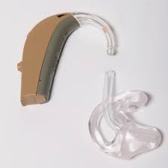

The tube and elbow push together to connect them.

This will become difficult to attach/ disconnect as the tube gets old so it MUST be replaced at least every 6months



